MODULE NUMBER 7

TESTING AND EVALUATING BNF IN THE FIELD

SUMMARY

Previous Modules discussed the nature of legume BNF, how farmers benefit from inoculation, methods of inoculating legumes, and effects of the environment on BNF and the response to inoculation. Understanding the principles of earlier modules is important for the extension agent to evaluate the success or failure of BNF in the field, and to make appropriate recommendations to farmers. This Module presents information to help the extension agent correctly identify problems with BNF in the field. Diagnostic methods are presented which help the agent interpret their observations and formulate proper solutions to problems. Methods to measure the response to inoculation are presented. These methods will help the extension agent design appropriate tests and experimental programs for determining whether farmers will benefit from inoculation. A discussion on the economics of inoculation and benefits to farmer income is provided in this Module.

KEY CONCEPTS

■ Training extension workers in applied BNF technology can help farmers make appropriate decisions about inoculating legume crops.
■ There is a logical process that leads to appropriate farmer recommendations to inoculate:
1. identifying problems with BNF in the field
2. designing appropriate tests to validate the value of inoculation
3. economic interpretation
4. training and extension work
5. recommendation to farmers to inoculate
■ Recommendation domains are groups of farmers who are likely to benefit from inoculation technology in a similar way. Farmers belong to a recommendation domain when conditions on their farms are similar.
■ Inoculation is an inexpensive technology; the risk of monetary loss to the farmers is low and the potential gain is very high.
■ Analysis of on-farm trials to test the response to inoculation requires special but simple approaches.
■ There are many ways to test the crop response to inoculation, including experiment station field experiments, greenhouse pot tests, soil surveys, and on-farm trials. Each has specific advantages.
■ Non-parametric statistics are an appropriate method to evaluate the response to inoculation in on-farm trials.
■ Economic analysis of inoculation technology compares the cost of inoculation to the increased revenue the farmer gets from inoculation.

IDENTIFYING THE NEED FOR INOCULATION AND
INTERPRETATION OF DATA

We recommend the inoculation of all nitrogen-fixing legume crops, because the cost of inoculation is small, and the potential benefits are large. Even when the farmer does not see measurable increases in yield, he may benefit from increased seed protein and improved N status of his soil due to inoculation.

However, if farmers are to accept inoculation of legume crops as a standard practice, they must be assured of benefit from the inoculation. Ultimately, they are most interested in the economic benefits. It is therefore important to correctly identify the need for inoculation when promoting BNF technology.

This module discusses some methods that can be used to identify and test problems related to legume BNF on the farm, and measure the benefit that farmers can expect from inoculation.

Farmers Benefit From Inoculation Technology Only When Lack of Nitrogen Limits the Yield of Their Legume Crop: Review of a Basic Principle

In Module 6 we learned that a legume crop can only benefit from inoculation if there was not enough nitrogen from other sources to support the growth of the crop. The other sources of nitrogen were identified as mineral N from the soil and fertilizer, and BNF from the native rhizobia already in the soil.

Programs promoting BNF technology should not mislead farmers into thinking that inoculation can benefit their crop system in any way except by providing more nitrogen. All inoculation trials and tests, whether they are on the farm or at the experiment station, are really testing whether nitrogen is limiting the productivity of the legume crop. This principle must be considered when examining legumes growing in farmers' fields or planning experimental programs to determine the need to inoculate legumes.

THE PROCESS OF DEVELOPING RECOMMENDATIONS TO FARMERS TO INOCULATE THEIR LEGUME CROPS

Technology can improve the productivity and welfare of the farm family. New technologies must be appropriate if they are to be adopted by farmers. An appropriate technology is socially and economically feasible in the context of the existing farm system, and there is a biological or physical need for the technology. The process necessary to make appropriate recommendations to farmers on the use of improved technology is long but not necessarily difficult. The planning process requires a realistic understanding of the technology, considering both the potential and limitations of the technology. An intimate knowledge of local conditions is also required.

Figure 7-1 is from a handbook titled, From Agronomic Data to Farmer Recommendations: An Economics Training Manual, Mexico D.F. (CIMMYT, Economics Program Mexico D.F.). The figure shows the process required to recommend a new technology to farmers. There are important elements of this process which must be addressed: 1) selecting an appropriate technology; 2) testing the technology under realistic farm conditions; 3) considering economic and social factors that may affect the acceptance of the technology by farmers. The following is a discussion of the important aspects of Figure 7-1 in relation to inoculation of legumes.

.
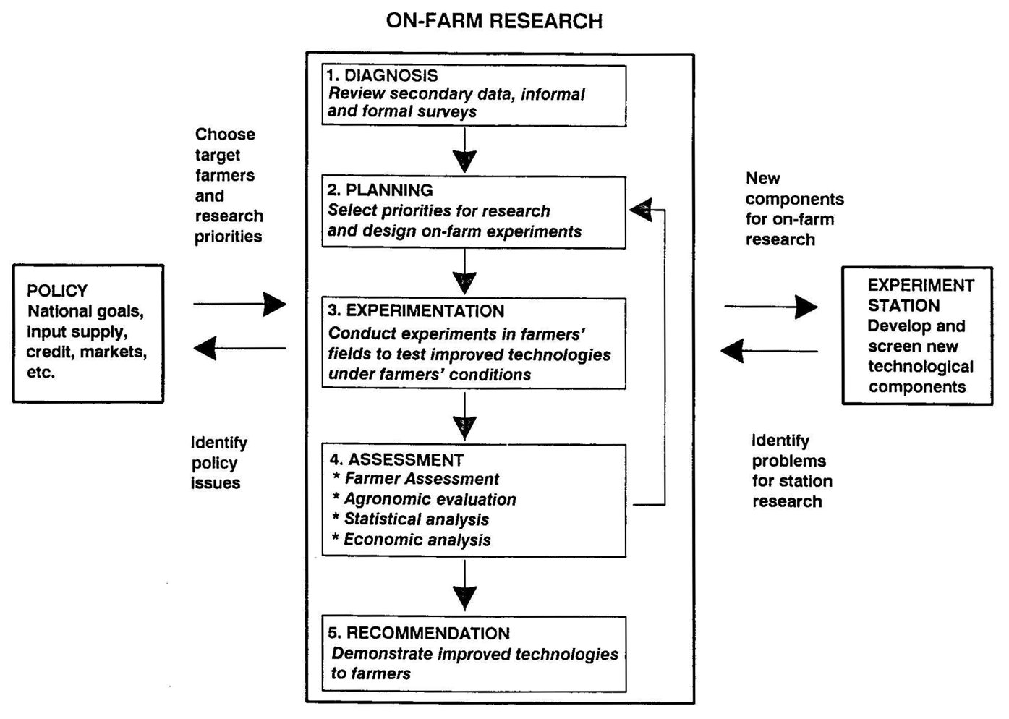
Figure 7-1. Stages of on-farm research. A logical sequence for developing farmer recommendations to inoculate legumes and assess the benefit farmers derive from inoculation. The process required to recommend new technology to farmers. Reproduced from, From Agronomic Data to farmer Recommendations: An Economics Training Manual, with permission from CIMMYT, Economics Program
Inoculation Technology and National Agricultural Goals

Research on the response to inoculation usually meets several existing national goals in agriculture. Reducing farm production costs, reducing environmental hazards, reducing importation of agricultural inputs, or import substitution of certain food commodities, are all national goals for agriculture. Inoculation technology has the potential to meet many of these national goals.

An Example. When high yielding varieties of rice and wheat were introduced, the use of nitrogen fertilizer was encouraged through a government subsidy of the fertilizer price. Although the programs were successful, the national governments have decided that the subsidies must be reduced and ultimately eliminated.

Farmers have come to rely on nitrogen fertilizers, even for legume production, since the price of fertilizer has been so inexpensive. Many national agricultural policies now call for the extension service to find alternative production methods that are less reliant on nitrogen fertilizers.

Experiment Station Results: Useful Preliminary Tests of Inoculation Technology

Experiments at research stations can produce valuable preliminary results on whether legumes may respond to inoculation. With the greater experimental control at the station, it is possible to detect smaller yield effects of inoculation than in farmers' fields, and examine other inputs that may affect the inoculation response.

Experiment station yields are usually greater than in farmers' fields, and therefore the response to inoculation may be greater than the farmer can get in his own field. It is important that recommendations are not based only on the results of a few trials at experiment stations. There is a vital need to validate the technology on the farm. In some cases, there may be an even greater response to inoculation on the farm, since rhizobia may have already been introduced to the experiment station in the past. With experiment station trials, extension workers gain valuable experience handling inoculants, growing the legume crop, and designing inoculation trials. These experiences will all improve the quality of later on-farm trials.

An Example: A representative from an inoculant producer approaches you to try a new inoculant for groundnut. You use the inoculant in two formal field experiments. The experiments are well managed. The yields in these trials are approximately 50% greater than local farmer yields, and there is a statistically significant response to inoculation. Your experience indicates that except for better management of the experiments, the conditions on experiment stations are similar to many farms in the region. These positive results mean that there is a possibility of obtaining a response to inoculation in the field, and further research planning is justified. Still, these results do not mean that the farmer will benefit from inoculating groundnut.

Diagnosis: Survey of Existing Data and Preliminary On Farm Observations of Legumes in the Field.

Deciding to plan on farm trials. At this stage the extension agent needs to make a preliminary survey to determine whether inoculation technology may be appropriate to selected farmers. The survey can be based on existing data from trials, and on a survey of the status of BNF in the farmers' fields. First, groups of farmers who may benefit from inoculation must be identified.

Recommendation domains: Identifying groups of farmers with similar conditions who will benefit from inoculation technology. Recommendation domains are groups of farmers that have similar crop systems, management, climate, and soil. We expect that farmers within a recommendation domain will benefit from inoculation in a similar way because of the common conditions on their farms. They can be identified through on-farm surveys.

An Example: Inoculation produced a yield increase in groundnut at the experiment station. The extension agent decides further investigation is warranted, and a survey of 40 farms where groundnut is planted after rice is planned. Interviews with farmers are conducted and groundnut crops are examined. An initial tabulation of the results follows:

Table 7-1. Nodulation and apparent nitrogen status of groundnut crops following rice in Abung Timur.
Leaf Color |  | Nodulation |  | Effective Nodules
Green | Yellow | Yes | No* | Yes | No
 |  | Number of Farms
32 | 8 | 26 | 14 | 22 | 4

*indicates less than 10 nodules per plant.

Table 7-1 indicates that only eight of the 40 farms had apparent nitrogen deficiency in their groundnut crops. If the extension agent only looked at leaf color, he may conclude that nitrogen deficiency in the groundnut crops is not frequent, and therefore further investigation on the value of inoculation is not necessary.

When nodulation is considered, the conclusions are different. Nodulation occurred on only 26 farms, and effective nodulation was observed on only 22 of those farms. There is an inconsistency between the observations of nitrogen deficiency and nodulation status of the groundnut crop. (Review Module 6 for the factors that affect the nitrogen and nodulation status of the crop.)

The on-farm interviews indicated that none of the farmers inoculated. Nodulation must be from native strains in the soil. The survey included a description of the crop history and management. The following is a summary of additional data from the 40 farms:

Table 7-2. Crop management effects on nodulation of groundnut following rice in Abung Timur.
 |  |  | Leaf Color |  | Nodulation |  | Effective
Crop Management |  | No. farms | Green | Yellow | Yes | No | Yes | No
Applied Fertilizer Nitrogen:
 | Yes | 12 | 12 | 0 | 0 | 12 | 0 | 0
 | No | 28 | 20 | 8 | 25 | 3 | 20 | 5
Years Between Groundnut
in Crop Cycle*
 | 1-2 | 22 | 21 | 1 | 18 | 4 | 18 | 0
 | >2 | 18 | 11 | 7 | 7 | 11 | 2 | 5

>2 years in crop cycle includes farmers planting groundnut for the first time.

When data about farm management is considered, the reason for nitrogen deficiency and lack of nodules is clearer. In this case, the extension agent generated two separate Recommendation Domains; application of fertilizer nitrogen and number of years between crops of groundnut. Farmers using fertilizer nitrogen do not have nodules on their groundnut, but their crops are healthy. There were a higher proportion of farms with nitrogen deficiency (yellow leaves), plants with no nodules, or ineffective nodulation, when groundnut was planted infrequently or for the first time.

From simple observations in the field and proper farmer interviews, the extension agent can define the farmer groups that are most likely to benefit from inoculation technology. The extension agent can now formulate experimental plans based on particular groups of farmers. Based on management, two groups of farmers become candidates for on farm inoculation trials: farmers applying nitrogen fertilizer who will benefit from lower production costs if BNF can substitute for N fertilizer; and farmers who plant legumes infrequently.

This type of survey is simple, and can provide an extension agent with valuable information on the status of BNF on the farm. While the information gathered at this stage is not quantitative, it forms a useful database to identify groups of farmers likely to benefit from inoculation.

Planning a Research and Demonstration Program on the Farm
During research planning, priorities are established to test inoculation technology at the farm level. Proper planning is important to ensure that experiments are appropriate within the context of existing farm operations. Groups of farmers (Recommendation Domains) with similar physical, biological and social environments are further defined at this phase.

Variables in addition to inoculation should be considered, including farm practices, and physical and economic conditions. From Module 6, we know that benefits from inoculation are increased when other management inputs are used by the farmer.

Example: If the groundnut crops of your farmers were green but very poorly nodulated, you might conclude that another factor in the environment was limiting yield of the crop. Soil test data may indicate that P was low in the soils. During the planning stage, these facts and observations should be considered. The farm trials might include P fertilization in addition to inoculation as treatments in the experimental design.

How many variables should be tested in on-farm trials? Designs should be simple, use methods that are easy for the farmer, and practical, so that many trials can be conducted. Farmers do not usually adopt many new practices at one time. It is important that the number of treatments to be tested be kept to a minimum.

How many trials are needed to test a technology? Many observations are required to overcome problems with random variation between farms. The variation interferes with measuring differences between treatments. It is difficult to develop a recommendation to a defined group of farmers with less than 15 trials. More trials are recommended, but the number required to make valid recommendations varies with:

1) the extent of the recommendation domain
2) the size of the response to inoculation in the recommendation domain
3) variability of crop growth at individual farms from year to year

Only a small yield increase from inoculation will justify the farmer's investment in inoculant. Large numbers of observations increase the likelihood a small positive benefit from inoculation will be detected. Climate differences between years may change the results, so the trials should be conducted for more than one year.

Remember that once the farmer has conducted a trial and used inoculant, his field will be in a new recommendation domain.

An Example: Based on the preliminary survey groundnut farmers were selected as a group likely to benefit from inoculation. Observations indicated BNF in groundnut crops was dependent on management. Two recommendation domains can be identified: farmers who currently apply nitrogen fertilizer to their groundnut, and farmers who do not apply nitrogen. These two groups were selected because the benefits from inoculation and the cost of production for the two systems are different, and they will require different treatments to develop a recommendation on whether farmers should inoculate. Information on crop history and management should be collected at the selected farms so yield results from the on-farm trials can be interpreted properly.

Trials testing the response to inoculating groundnut:
I. Farmers not applying nitrogen fertilizer.
Question to be answered by the trial: Do farmers planting groundnut after rice benefit from inoculation with rhizobia under existing management practices?
Proposed design:
1) Treatments:
a) Inoculated
b) Uninoculated
2) Inoculation method: Two-step seed coating; 10% sugar solution sticker; 300 g inoculant per 65 kg seed.
3) Management: Standard farmer practices
4) Replications within farm: 3
5) Number of farms: 15
6) Response measurement:
a) Seed yield
b) Seed protein
c) Nodulation
d) Leaf color

II. Farmers using nitrogen fertilizer as a standard practice.
Question to be answered by the trial: Can inoculation with rhizobia increase yield, and substitute for application of nitrogen fertilizer to groundnut following rice?
Proposed design:
1) Treatments:
a) Inoculated
b) Uninoculated
c) Uninoculated plus nitrogen fertilizer

Note that this is not a complete factorial experiment where every combination of treatments is used. The question to be answered by the trials is not whether inoculation and fertilizer nitrogen increase yield. The question is whether inoculation increases yield and can substitute for fertilizer nitrogen.

2) Inoculation method: Two-step seed coating; 10% sugar solution sticker; 300g inoculant per 65 kg seed.
3) Management: Standard farmer practices
4) Replications within farm: 3
5) Number of farms: 15
6) Response measurement:
a) Seed yield
b) Seed protein
c) Nodulation
d) Leaf color

Information to collect from on farm interview:

1) Inoculation history
2) Management: planting density, fertilizers, cultivar, field preparation, date of planting and harvest.
3) Crop history: five-year history of species and management
4) Soil type: observations of local classification, measure pH
5) Farmer's knowledge of inoculation

Conducting Inoculation Trials on the Farm: Some Basic Principles

Exact instructions for conducting on-farm inoculation trials cannot be provided since local environmental and social conditions affect the design and execution of the trials. Local experience with other on-farm trials should be considered. The following are some suggestions and factors to consider when conducting on-farm inoculation trials:

1) In many cases inoculation technology is so new that the extension agent will have to work closely with each farmer to ensure that the inoculant is handled and applied properly. The extension agent should consider holding training sessions on inoculant storage, application and monitoring the effects of the inoculant on crop growth.
2) When conducting inoculation trials the extension agent must know that the inoculant used is of good quality. The inoculation trials should not be used to test inoculant quality. Laboratory methods to test inoculant quality are more effective and much less expensive than field trials.
3) Application rates and methods of inoculation should consider farmer cultural practices for the legume. For example, if the farmer usually uses fungicides on his groundnut seeds, he should apply them in the inoculation trial. The extension agent should then recommend soil inoculation instead of seed inoculation, unless he knows that the fungicide will not affect the rhizobia on the seed.
4) The inoculation trial should use rates of inoculant that the farmer can afford, but still meet minimum quantities required for good nodulation. It is better to ensure delivery of good quality inoculant to farmers than to recommend excessive rates of inoculation.
5) Care should be taken during planting inoculation trials. It is easy to contaminate the uninoculated treatment with rhizobia from the inoculant. Seed for the uninoculated plots should be kept away from the inoculation process. It is helpful if the uninoculated plots can be planted and covered before the inoculation and planting of seed for the inoculated treatments; however, planting uninoculated treatments first is only acceptable if the entire trial can be planted within a few hours.
6) Use repeated observations (replications) of treatments on a single farm, and take the average or mean values of these replications. The soil in farmers' fields is often variable. Using the mean of several observations gives a more accurate indication of the response to inoculation at a particular site. The repeated treatments should be put in "blocks." For example, in Figure 7-2, the paired Inoculated and Uninoculated treatments are placed in Blocks along a slope. The higher portion of the slope may have poorer soil due to erosion. By arranging the experiment along the slope, the conditions within each block are similar, even if conditions between blocks may be different. Putting replications in blocks reduces error in the statistical analysis of on-farm trials.

Figure 7-2. Treatments are repeated and placed in blocks on a slope.
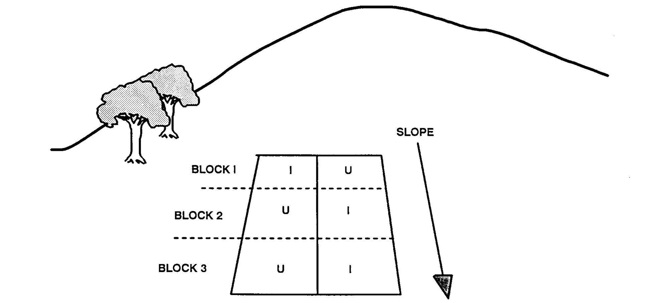

Assessment of Inoculation Trial Data
Assessment of inoculation trials takes place on three levels:
1) farmer acceptance
2) statistical evaluation
3) economic evaluation
All three levels of assessment must be approached rationally within the context of the existing farm system.

Assessment by the farmer. The extension agent researcher needs to include the farmer in the assessment of the experimental results and consider the farmer's observations on both the practicality and benefits of using inoculant. Farmers' doubts about the use of inoculant must be addressed. Many times these doubts can be overcome through informational campaigns, but farmers' observations may lead to the need for additional research.

An example: Groundnut farmers apply fungicide to the seed. The inoculation treatment in the trial called for a liquid application of inoculant to the soil rather than seed coating. After the harvest, the farmers say that the inoculation treatment increased yields in many cases, but there is agreement that application of liquid inoculant to the soil is too much work. Further research is then needed to identify application methods or compatible fungicides that will make inoculation acceptable to farmers. In this case the on-farm trials return to the planning stage.

Statistical analysis of on-farm inoculation trials. Statistical analysis helps the researcher evaluate reliability of the data collected. Based on that reliability, the researcher can then apply economic principles to determine the financial benefit farmers can expect from inoculation. Statistical analysis is a useful tool. Through probability statements, the reliability of the treatment differences are determined. Statistical methods compare the difference in yield between inoculated and uninoculated crops to the amount of random or unexplained differences in the trials.
Non-Parametric statistics are a relevant method to evaluate the response to legume inoculation in series of on-farm trials.

What are Non-Parametric Statistics? Non-Parametric Statistics are simpler to use than Analysis of Variance (ANOVA) techniques, commonly used to analyze single and multi-site farm trials. Based on our experience, ANOVA techniques usually require a yield increase from inoculation of about 200 kg/ha to be considered statistically significant. Non-parametric statistics detect significant responses to inoculation in series of farm trials, based on the frequency responses observed, rather than the magnitude of the yield increase. Sometimes the yield increases due to inoculation may not be considered statistically significant by ANOVA techniques, but the non-parametric statistics do not require that the data meet assumptions of normality required by the ANOVA.

Most Non-Parametric statistical methods are based on a system where data are ranked according to their magnitude, and then assigned a number indicating their rank. Non-Parametric statistics are often called Ranking Tests. Tables are then used to determine whether the differences between inoculated and uninoculated crops are statistically significant. You would not use this method to analyze the data from a single farm trial, but rather for analyzing combined results of a series of farm trials.

Wilcoxon's Signed Rank Test for Paired Data: There are many non-parametric statistical tests. The Wilcoxon Signed Rank Test is particularly useful for inoculation trials, since the treatments of on-farm trials are always in pairs.

Table 7-3. Results of 15 on-farm inoculation trials of groundnut following a rice crop in Abung Timur. Data are the mean of three replicates.
Yield
Farm Inoculated Uninoculated Difference Signed Rank
 | - - - - - - - - - - - - kg seed/ha - - - - - - - - - - - - -
1 | 961 | 909 | 52 | 10
2 | 980 | 930 | 50 | 9
3 | 1065 | 1090 | 25 | -5
4 | 583 | 575 | 8 | 1
5 | 705 | 741 | 36 | -8
6 | 1274 | 1038 | 236 | 15
7 | 872 | 840 | 332 | 6.5
8 | 626 | 635 | 9 | -2
9 | 743 | 712 | 131 | 14
10 | 1294 | 1186 | 108 | 11
11 | 1052 | 1069 | 17 | -4
12 | 798 | 766 | 32 | 6.5
13 | 1019 | 904 | 115 | 12
14 | 1489 | 1364 | 125 | 13
15 | 872 | 883 | 11 | -3
Average | 962 | 909 | 53
Median response to inoculation 36 kg seed/ha.

The median means 50% of the farmers had a response equal to or greater than 36 kg seed/ha.

An Example: Table 7-3 show data from 15 on farm trials using the same design presented earlier in this Module; two treatments (inoculated, uninoculated) and three replications of each treatment arranged in blocks on each farm. The differences between the average inoculated and uninoculated yields on each farm are ranked according to the instructions that follow. Analysis of variance of the individual trials indicate that the yield increases due to inoculation is significant only for Farm 6.

Even though the trials were conducted on farms from the same region and crop management and crop system was similar, the inoculation response and the yield of groundnut varies between farms. Average response to inoculation was only 53 kg seed/ ha.

The median means half the farms observed yield increases from inoculation greater than 36 kg seed/ha. Negative responses to inoculation occurred on five farms but averaged only 19 kg seed/ha. It appears that there should be a recommendation for farmers to inoculate, but the data should be statistically analyzed for the extension agent to be confident in his recommendation.

We recommend that the data be analyzed by simple non-parametric statistics. This evaluation will tell the extension agent how much confidence to have in using the results of these trials as a basis to recommend inoculation. The following is a simplified procedure for conducting a Wilcoxon Signed Rank Test.

Procedure to Evaluate Data from Abung Timur by the Wilcoxon Signed Rank Test:

1. The data must be paired. Only two treatments are compared.
2. Subtract the yield of Uninoculated from the yield of Inoculated. The difference is calculated without a negative or positive sign at this time.
3. Rank the differences according to their size. The lowest difference is given a rank of 1 (Farm 4) and the largest difference is given a rank of 15 (Farm 6).
4. When two differences are equal, assign each the average of the next two ranks. Farm 12 and Farm 7 both had a response to inoculation of 32 kg/ha. These two farms are each assigned the average of ranks 6 and 7 which is 6.5.
5. Assign negative signs to the ranks of farms where the yield of the uninoculated was greater than the inoculated (Farms 3,5,8,11,15) and positive signs to farms where there was a response inoculation (Farms 1,2,4,6,7,8,9,10,12,13,14).
6. Add the total of signed ranks for farms with positive and negative ranks. Sum of positive ranks = 98; Sum of negative ranks = 22.

If the sum of the negative ranks is ever greater than the sum of the positive ranks, there is no significant yield increase due to inoculation.

Is there a significant yield increase due to inoculation of groundnut in Abung Timur? Use Table 7-4 and find the number of observation pairs (number of farms with inoculated and uninoculated yields). In this case the number of paired observations is 15. The "sum of ranks" in Table 7-4 refers to the sum of the negative ranks.

If your sum of the negative ranks is less than or equal to the figures listed in Table 7-4, then you know that the increased yield due to inoculation is significant at the 95% or 99% confidence level. With 15 pairs of observations, Table 7-4 indicates that your sum of negative ranks must be 25 or less to have 95% confidence level of probability that inoculation increases yield. Since the rank of the negative responses to inoculation in Abung Timur was 22, we can accept that "Inoculation increased yield of groundnut following a rice crop in Abung Timur" at a 95% level of confidence. In other words, we are 95% certain that there was a real positive response to inoculation. The increase, however, is not significant at the 99% confidence level because the negative sum of ranks is greater than 16.

Table 7-4. Sum of Ranks for the Wilcoxon Signed Rank Test at the 95% and 99% Levels of Confidence. When the sum of negative ranks (negative response to inoculation) is equal or smaller than numbers in the table, inoculation had a significant positive effect on yield.
 | Confidence Level
Number of Observations | 95% | 99%
Pairs | - - - - - - - - - - Sum of Ranks - - - - - - - - - -
7 | 2 | 0
8 | 2 | 0
9 | 6 | 2
10 | 8 | 3
11 | 11 | 5
12 | 14 | 7
13 | 17 | 10
14 | 21 | 13
15 | 25 | 16
16 | 30 | 19

Source: Snedecor, G. and W. Cochran. 1967. Statistical Methods, 6th edition. Iowa State University Press. Ames Iowa, USA.

What if there are more than 16 pairs of observations?

1. A table is not required for the Wilcoxon Signed Rank Test with more than 16 pairs.
2. If the sum of negative ranks is greater than the sum of the positive ranks, there is no significant yield increase due to inoculation.
3. When the sum of negative ranks is less than the positive calculate the following:
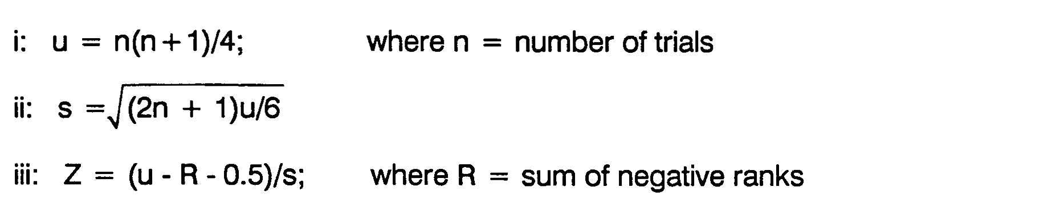

4. If Z > 1.64 then inoculation increased yield at the 95% confidence level.

What level of confidence is required for on-farm inoculation trials? There are no rules dictating the level of confidence that should be obtained before accepting that yield increases are significant. The level of confidence in any experimental program should reflect the risk to the farmer if the analyses produced incorrect results. If new technologies being tested require large investments, then the extension agent should require more statistical confidence in the on-farm trial data. When the risk to the farmers is low, as in the case of recommending inoculant technology, the extension agent does not need a high confidence level to recommend the technology.

What does the non-parametric analysis tell us about the yield of the inoculated and uninoculated crops?

Non-parametric statistics are not used to estimate the average response to inoculation. Non-parametric statistics indicate the confidence that the median response to inoculation is greater than zero. The data of Table 7-5 has a median response to inoculation of 36 kg seed/ha. This means half of the farmers had a response to inoculation of 36 kg/ha or more. In this case, the median value is less than the average increase of 53 kg/ha. The median more accurately predicts the yield increase a farmer can expect if he inoculates.

The Economic Benefit from Inoculation

Farmers invest in new technology only if they are convinced there is a positive economic return to the investment. There is no guarantee that any input the farmer uses will increase his income above the cost of the input with each crop. For example, many farmers apply nitrogen fertilizer to their maize or rice crops. The economic benefit they obtain from the nitrogen fertilizer may be negative in drought conditions where the crop cannot use the nitrogen applied. Investing in agricultural inputs involves risk to the farmer. It is the job of extension agents to develop management recommendations that will increase the farmer's income but minimize the economic risk the farmer must assume in adopting new technology.

A training manual on the economic interpretation of on farm trials titled "From Agronomic Data to Farmer Recommendations" is available from The International Maize and Wheat Improvement Center (CIMMYT). The following is adapted from this publication.

Costs, Benefits, and Risk of Inoculation

The relationship between cost, benefit, and risk determine the economic return for farmers using inoculant. Inoculation technology has some characteristics that are different than other agricultural technologies when evaluating this relationship.

Cost. Inoculant is inexpensive, and rarely exceeds 10% of production costs of the legume crop. Unlike other inputs, the cost of transporting the inoculant to the farm is very small. Inoculant does not require special application equipment, and requires very little extra labor to apply.

Benefits and Risk. As can be seen in Table 7-3 and in Module 6, the potential benefits from inoculation are very large. In some cases, especially when there is a long history of cultivating the legume crop, farmers may not get yield increases when they inoculate. Therefore, there is a risk of not obtaining a response to inoculation. Negative responses to inoculation are usually small and due to random variation in field trials. The risk of inoculation failure is therefore limited to the cost of the inoculant. In contrast, with other inputs, the risk of failure sometimes means decreased yield in addition to the high cost of the input.

There is some debate whether economic analysis of inoculation technology is necessary because of the low cost of using the inoculant, minimum adverse risk, and the large potential returns that can be obtained. Many view the investment in inoculant as an inexpensive insurance for maximal BNF. Still, economic analysis is important if farmers are to be convinced to use inoculant.

Analysis of the Economic Benefit from Inoculation.

Marginal analysis is the calculation of increased income, above the cost of inoculation, due to investment in the inoculant. The marginal analysis does not calculate the farmer's total income. It only considers the additional money the farmer will make if he uses inoculant. In the following analysis, prices are in $US. Results will differ according to local prices of inoculant, labor, and grain.

An Example:
Costs of inoculation technology:
 | Cost
1. Cost of inoculant/ha. | $2.75
2. Labor to inoculate ($0.50/h) | 0.25
3. Materials (sticker, bags) | 0.10
Total Costs/ha. | $3.10

Table 7-5. Marginal analysis of inoculation trials in Abung Timur, listing yield increase due to inoculation, price of groundnut, additional income due to inoculation (income increase), cost of inoculation, net income due to inoculation (income increase minus cost), and marginal rate of return (percent return on investment).
Median Yield Increase from  Inoculation | Price of Groundnut | Income Increase | Cost of Inoculation | Net Income | Marginal Rate  of Return
kg/ha | - - - - - - - - - - - - - - - $US - - - - - - - - - - - - - - |  |  |  | %
36 | 0.25/kg | 9.00 | 3.10 | 5.90 | 190

Marginal rate of return from inoculation is calculated by dividing net income by the cost of inoculant. This calculation, $5.90/$3.10 = 1.90, means that for each dollar invested in inoculation technology, the farmer can expect to get $1.90 net profit from inoculation, or 190% return on investment. Farmers usually require greater than a 50% rate of return to adopt a new technology, depending on economic conditions on the farm.

The marginal benefit from inoculation to these farmers is small. The marginal benefit is based on the median response to inoculation. At least 50% of the farmers will get a marginal rate of return on investment greater than 190%.

Break-Even Analysis. The break-even yield response is the level where increased income due to inoculation equals the cost of inoculant. To assess the risk that farmers assume by investing in inoculant, the proportion of farmers losing money (increases less than break-even yield) must be determined. The break-even yield response to inoculation is calculated by dividing the cost of inoculation ($3.10), by the price the farmer gets for each kg of seed.

Table 7-6. Break even analysis of farmers using inoculant on
groundnut following a rice crop.
Cost of Inoculant | Price of Groundnut | Break Even Yield
- - - - - - - - - - $US - - - - - - - - - - |  | kg/ha
$3.10 | $0.25 | 12.4
% Farmers above break-even yield = 60% (see Table 7-5)

Nine farmers (60%) of the total from Table 7-3 had increased net benefit from inoculation. This analysis of the proportion of farmers above the break even yield gives an idea of the risk that farmers face by purchasing inoculant.

The farmer is willing to take more risk if the potential gain is large or if the potential risk is small. The average increased income for nine farmers was $11.58. The average net loss of 6 farmers was -$5.65. The risk of loss then is 0.4 X $5.65 = $2.26 (the proportion of farmers losing money on inoculant X the expected loss). This risk of loss is extremely low compared to the potential gain the farmer can realize with inoculation.

The conditions on farms where there is a negative return on investment in inoculant should be studied. Perhaps these farmers belong to a different recommendation domain than the others. This information will help to design other trials that may improve the inoculation response on these farms.

The Farmer Recommendation.

From the preliminary survey, field trial data, and economic analysis, there are strong reasons to recommend inoculation to farmers growing groundnut after rice in Abung Timur. This recommendation can be made with confidence, since the majority of farmers will benefit from inoculation. The recommendation can be based solely on yield and current costs and prices. Other benefits not considered in this analysis include greater protein content of seed and greater N fertility of the soil with inoculation.

DIAGNOSES OF BNF PROBLEMS AND MEASURING THE RESPONSE TO LEGUME INOCULATION

Information on how environment and management influences the response to legume inoculation is necessary in the design of on-farm and experiment station trials. It is important to remember the Law of the Minimum, the appearance of effective and ineffective nodules, and how mineral nitrogen and native rhizobia in the soil affect the response to inoculation, when you evaluate BNF in the field or design research programs to test inoculation response.

Following is a discussion of three levels of diagnosing problems with legume BNF and measuring the response to legume inoculation. These levels are 1) observations in farmers' fields; 2) greenhouse pot tests; and 3) field experiments. There are more details in the Demonstrations for Module 7. The uses of the various techniques are discussed in the following sections.

Examining Legumes in the Field: Simple Diagnostic Methods to Assess the Status of BNF in the Farmer's Field.

Preliminary surveys of farmers' fields are important to detect problems with BNF. These observations are useful to help the extension agent develop an experimental plan and identify a `recommendation domain' that requires further research.

Figure 7-3 provides a useful summary of situations that extension agents may see in the field. The descriptions are divided into two management categories: 1) inoculated; 2) uninoculated. Information on whether or not the farmer inoculated is needed to interpret observations. Although the descriptions of the field situations are simple, it is often possible to make recommendations to the farmers. For example, nodulation failure and nitrogen deficient plants almost always indicate that there are no rhizobia in the soil or in the inoculant. Information on management, soil, and climate factors will also help the extension agent to interpret his observations. By comparing observations on crops on farms in the same area, you can detect whether differences in management may affect BNF.

Elements of a preliminary survey of farm fields:

1. Crop history
2. Inoculation history
3. Management
4. Soil and climate information

Conducting the on farm interview. Most farmers want to help extension agents obtain the information they require. In fact, many farmers are so eager to please extension agents that they sometimes give answers they think the extension agent wants to hear. It is very important to ask questions that need more than a 'yes' or 'no' answer.
An example: During the interviews on farms in Abung Timur the survey asked the frequency of groundnut cultivation in the last five years. The extension agent should not ask farmers: "Did you plant groundnut last year?" The farmer may think you look favorably on groundnut cultivation and try to provide you with a favorable response. Ask the farmer: "What crops have you planted following the rice crop during the last five years?" This approach is more likely to produce accurate information for your survey.
Figure 7-3. Situations commonly observed in farmers fields and their explanations.

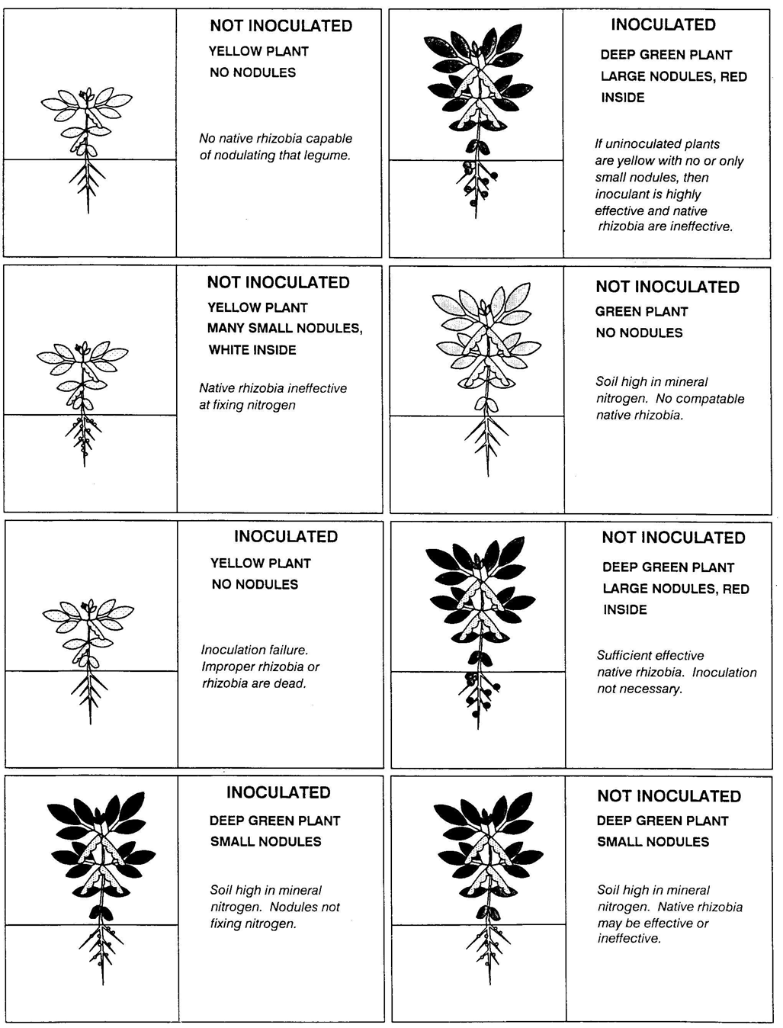
Examining Legume Crops in the Field

Standardizing Observations. Observations should be standardized for a meaningful survey. Criteria used to make an assessment must not vary between farms.

It is simple to standardize leaf color observations. This observation is important to detect nitrogen deficiency in crops. Always examine leaves at the same position on the plant. Usually, it is best to examine the most recently developed leaf. Compare the leaf color with color samples that have been selected as standards. Try to compare farms that have crops at the same stage of maturity, since the nitrogen status of a crop changes with the stage of growth.

Observations on the nodulation of legumes growing on the farm provides important information about the rhizobia in the soil. Random plants in the field should be sampled. The nodules on most species will become detached if plants are pulled from the soil. Instead, the root system must be lifted from the soil with a digging tool, and the soil gently removed. Develop a rating system for the nodulation of the crop, including effectiveness, size, distribution, and abundance. It is important to have experience with the nodulation characteristics of the species you are working with before you design the rating system.

Variation in the Field. Variation of soil N, crop growth, and native rhizobia within the farmer's field is common and must be considered. Sample plants at random throughout the field. Knowledge of previous management practices on the farm will help to select sampling areas. If the farmer inoculated part of his farm, the introduced rhizobia will not necessarily move to other parts of the farm.

Greenhouse Methods to Assess the Response to Inoculation.

Greenhouse tests of the response to legume inoculation are simple diagnostic tools. They can provide the extension agent with information on how inoculation is likely to affect the yield of legumes in the field. Demonstration 2 for Module 7 describes how to conduct inoculation trials using soil from farmers' fields.

Results from properly performed pot experiments agree well with results from field experiments, and they can be confirmed in the field. The advantage that pot experiments have is that the extension agent can easily test inoculation response in many different soils.

An Example: Observations of groundnut growing in fields after rice cultivation in Abung Timur indicated nodulation varied greatly between fields. Information from the on-farm interview suggested that management practices such as nitrogen application and frequency of groundnut cultivation affected nodulation of the crop. Two basic questions about the need to inoculate groundnut can be easily answered with pot experiments. 1) Will farmers who currently apply nitrogen to their groundnut crops benefit from inoculation when no nitrogen is added?; 2) Does the frequency of groundnut cultivation affect the response to inoculation by groundnut?

A suggested design: Select farms for soil sampling based on management: 1) farms applying fertilizer nitrogen to groundnut and cultivating groundnut every year; 2) farmers planting groundnut every year without adding fertilizer nitrogen; 3) farms with no groundnut cultivation in the last four years.

At least three farms in each management category should be selected. Collect enough soil from each site to fill six pots and handle according to instructions in Module 7 Demonstration 2.

There are at least two treatments required for this experiment: inoculated; uninoculated. There should be at least three replications for each treatment, and more if possible. Dry weight or total nitrogen yield should be determined after harvesting the plants. The same non-parametric statistical analysis can be performed on the pot tests as the on-farm trials.

The extension agent should also consider using greenhouse pot experiments to test the performance of inoculant under different levels of management. Since the work involved with pot tests is much less than in the field, the extension agent can often obtain preliminary results that indicate further research needs to increase legume yields.

Other Survey Techniques that Indicate the Need for Farmers to Inoculate Legumes.

Recent advances in technology have developed survey techniques that predict the response to inoculation. These techniques are more quantitative than the on-farm survey presented earlier. The techniques require that researchers count rhizobia in the soil. While the counting technique is not difficult, it does require special training and facilities that are not available to most extension agents.

The techniques to predict the response to inoculation are very cost effective compared to field trials. If there is a need for such a survey in your region, you should contact professionals at the national university with training in BNF research. They can get assistance to conduct a survey from NifTAL.

THE FORMAL FIELD EXPERIMENT TO TEST INOCULATION RESPONSE.

There is information on how to conduct a formal field experiment in Module 7 Demonstration 1. This type of experiment is usually large, with numerous treatments. It has a well defined experimental design for both controls and statistical analysis. This type of trial is more suited for experiment stations than on-farm sites.

Experiment stations trials are good opportunities to demonstrate the potentials of the latest technologies. Farmers can also learn about the interaction between management variables, since these experiments can have a more complex design than the on-farm trials.

An Example: Some farmers of Abung Timur plant groundnut after rice on highly weathered soils. These soils are red in color and yields are usually low. The soil science department of the local University says that these soils are deficient in phosphorus. There are currently no recommendations on the management of these soils for groundnut cultivation. The objectives of the experiment are:

1. Test the response to inoculation by groundnut in these soils.
2. Develop data that describes the response of groundnut to various rates of P fertilization.
3. Test the interaction between P fertilization management and the response to inoculation.

Experimental Design: Split plot design: Main plots (four P fertilization levels including control); Sub-plots (inoculated; uninoculated); 4 replications.

Data collection: Soil P test values; P and N concentration in leaf tissue at flowering; biomass at flowering, mid-pod fill, maturity; nodule dry weight at flowering.

This design is presented in more detail in Module 7 Demonstration 1.

Review, Discussion and Case Studies

1. Form a strategy to make inoculation recommendations to farmers in your district:

What are the crop systems?
Which are the recommendation domains most likely to benefit from inoculation? Design an evaluation and systematic research program including data analysis.

2. What are some of the social and economic considerations when promoting inoculation technology in your area?
3. Compare the use and promotion of inoculation technology with other agricultural technologies in your district. Evaluate several agricultural technologies in terms of potential return and risk to the farmer, and compare to the use of inoculation technology.
4. The extension service has recommended that starter nitrogen be applied to legumes at planting. Develop a research program to answer:
1) Is this recommendation valid?
2) Can inoculation substitute for starter N?
3) What are the costs and benefits of each technology?

SUGGESTED LESSON PLAN FOR MODULE 7

TIME: 2-3 hours +

OBJECTIVES:

Knowing how to measure the response to inoculation and how to evaluate SUccess or failure of BNF in the field. Knowing the process required to make recommendations to farmers to inoculate their legumes.

MATERIALS:

Demonstrations 7/1 and 7/2

Training Aids for Module 7

STEPS:

1. Display key concepts and other appropriate-training aids.
2. Much of the practical material in this module can be combined with the field experience gained in Module 6.
3. Lectures should be frequently interspersed with discussion and question and answer sessions. Situational case studies from the participant's actual experience win provide the kinds of information necessary to arrive at good recommendations for farmer's decision making.
KEY CONCEPTS

Training extension workers in applied BNF technology can help farmers make appropriate decisions about inoculating legume crops.

There is a logical process that leads to appropriate farmer recommendations to Inoculate:
1. identifying problems with BNF In the field
2. designing appropriate tests to validate the value of Inoculation
3. economic interpretation
4. training and extension work
5. recommendation to farmers to inoculate

Recommendation domains are groups of farmers who are likely to benefit from inoculation technology in a similar way. Farmers belong to a recommendation domain when conditions on their farms are similar.

Inoculation is an inexpensive technology; the risk of monetary loss to the farmers is low and the potential gain is very high.

Analysis of on-farm trials to test the response to inoculation requires special but simple approaches.

There are many ways to test the crop response to Inoculation, Including experiment station field experiments, greenhouse pot tests, soil surveys, and on-farm trials. Each has specific advantages.

Non parametric statistics are an appropriate method to evaluate the response to Inoculation In on-farm trials.

Economic analysis of Inoculation technology compares the cost of inoculation to the increased revenue the farmer gets from Inoculation.

